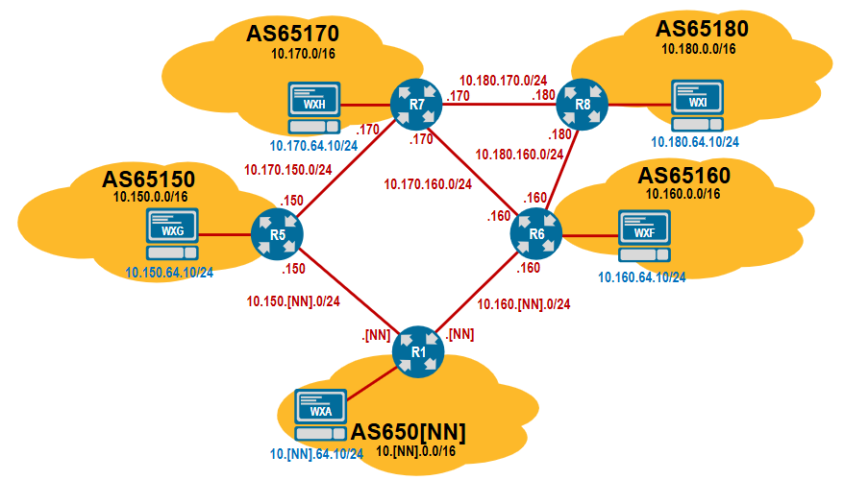

🔵 R1 – AS 65046
Connected to:
- R5 (AS 65150) → 10.150.46.0/24
- R6 (AS 65160) → 10.160.46.0/24

1️⃣ Start BGP
conf t
router bgp 65046
router-id 10.46.0.1
bgp log-neighbor-changes

2️⃣ Configure eBGP neighbors
neighbor 10.150.46.150 remote-as 65150
neighbor 10.160.46.160 remote-as 65160

3️⃣ Secure the neighbors
neighbor 10.150.46.150 password BGP46
neighbor 10.150.46.150 ttl maximum-hop 1

neighbor 10.160.46.160 password BGP46
neighbor 10.160.46.160 ttl maximum-hop 1

4️⃣ Advertise aggregated prefix
ip route 10.46.0.0 255.255.0.0 Null0

router bgp 65046
network 10.46.0.0 mask 255.255.0.0

🔵 R5 – AS 65150
Connected to:
- R7 (AS 65170) → 10.170.150.0/24
- R1 (AS 65046) → 10.150.46.0/24

1️⃣ Start BGP
conf t
router bgp 65150
router-id 10.150.0.1
bgp log-neighbor-changes

2️⃣ Configure eBGP neighbors
neighbor 10.170.150.170 remote-as 65170
neighbor 10.150.46.46 remote-as 65046

3️⃣ Secure the neighbors
neighbor 10.170.150.170 password BGP46
neighbor 10.170.150.170 ttl maximum-hop 1

neighbor 10.150.46.46 password BGP46
neighbor 10.150.46.46 ttl maximum-hop 1

4️⃣ Advertise aggregated prefix
ip route 10.150.0.0 255.255.0.0 Null0

router bgp 65150
network 10.150.0.0 mask 255.255.0.0

🔵 R6 – AS 65160
Connected to:
- R7 (AS 65170) → 10.170.160.0/24
- R1 (AS 65046) → 10.160.46.0/24

1️⃣ Start BGP
conf t
router bgp 65160
router-id 10.160.0.1
bgp log-neighbor-changes

2️⃣ Configure eBGP neighbors
neighbor 10.170.160.170 remote-as 65170
neighbor 10.160.46.46 remote-as 65046

3️⃣ Secure the neighbors
neighbor 10.170.160.170 password BGP46
neighbor 10.170.160.170 ttl maximum-hop 1

neighbor 10.160.46.46 password BGP46
neighbor 10.160.46.46 ttl maximum-hop 1

4️⃣ Advertise aggregated prefix
ip route 10.160.0.0 255.255.0.0 Null0

router bgp 65160
network 10.160.0.0 mask 255.255.0.0

🔵 R7 – AS 65170
Connected to:
- R5 (AS 65150) → 10.170.150.0/24
- R6 (AS 65160) → 10.170.160.0/24
- R8 (AS 65180) → 10.180.170.0/24

1️⃣ Start BGP
conf t
router bgp 65170
router-id 10.170.0.1
bgp log-neighbor-changes

2️⃣ Configure eBGP neighbors
neighbor 10.170.150.150 remote-as 65150
neighbor 10.170.160.160 remote-as 65160
neighbor 10.180.170.180 remote-as 65180

3️⃣ Secure the neighbors
neighbor 10.170.150.150 password BGP46
neighbor 10.170.150.150 ttl maximum-hop 1

neighbor 10.170.160.160 password BGP46
neighbor 10.170.160.160 ttl maximum-hop 1

neighbor 10.180.170.180 password BGP46
neighbor 10.180.170.180 ttl maximum-hop 1

4️⃣ Advertise aggregated prefix
ip route 10.170.0.0 255.255.0.0 Null0

router bgp 65170
network 10.170.0.0 mask 255.255.0.0

🔵 R8 – AS 65180
Connected to:
- R7 (AS 65170) → 10.180.170.0/24

1️⃣ Start BGP
conf t
router bgp 65180
router-id 10.180.0.1
bgp log-neighbor-changes

2️⃣ Configure eBGP neighbor
neighbor 10.180.170.170 remote-as 65170

3️⃣ Secure the neighbor
neighbor 10.180.170.170 password BGP46
neighbor 10.180.170.170 ttl maximum-hop 1

4️⃣ Advertise aggregated prefix
ip route 10.180.0.0 255.255.0.0 Null0

router bgp 65180
network 10.180.0.0 mask 255.255.0.0

✅ Final Verification Commands (Run Anywhere)
show bgp ipv4 unicast summary
show bgp ipv4 unicast
show ip bgp neighbors

